**Assisted Practice: 3.16 Create an IAM Role**

This section will guide you to:

* Create an IAM role

This lab has four subsections, namely:

3.16.1 Creating an IAM role

3.16.2 Adding AWS policy to the role

3.16.3 Providing a key and a value for the role

3.16.4 Pushing the files to GitHub repositories

**Step 3.16.1:** Creating an IAM role

* In the IAM panel, click on *Roles* -> *Create role*

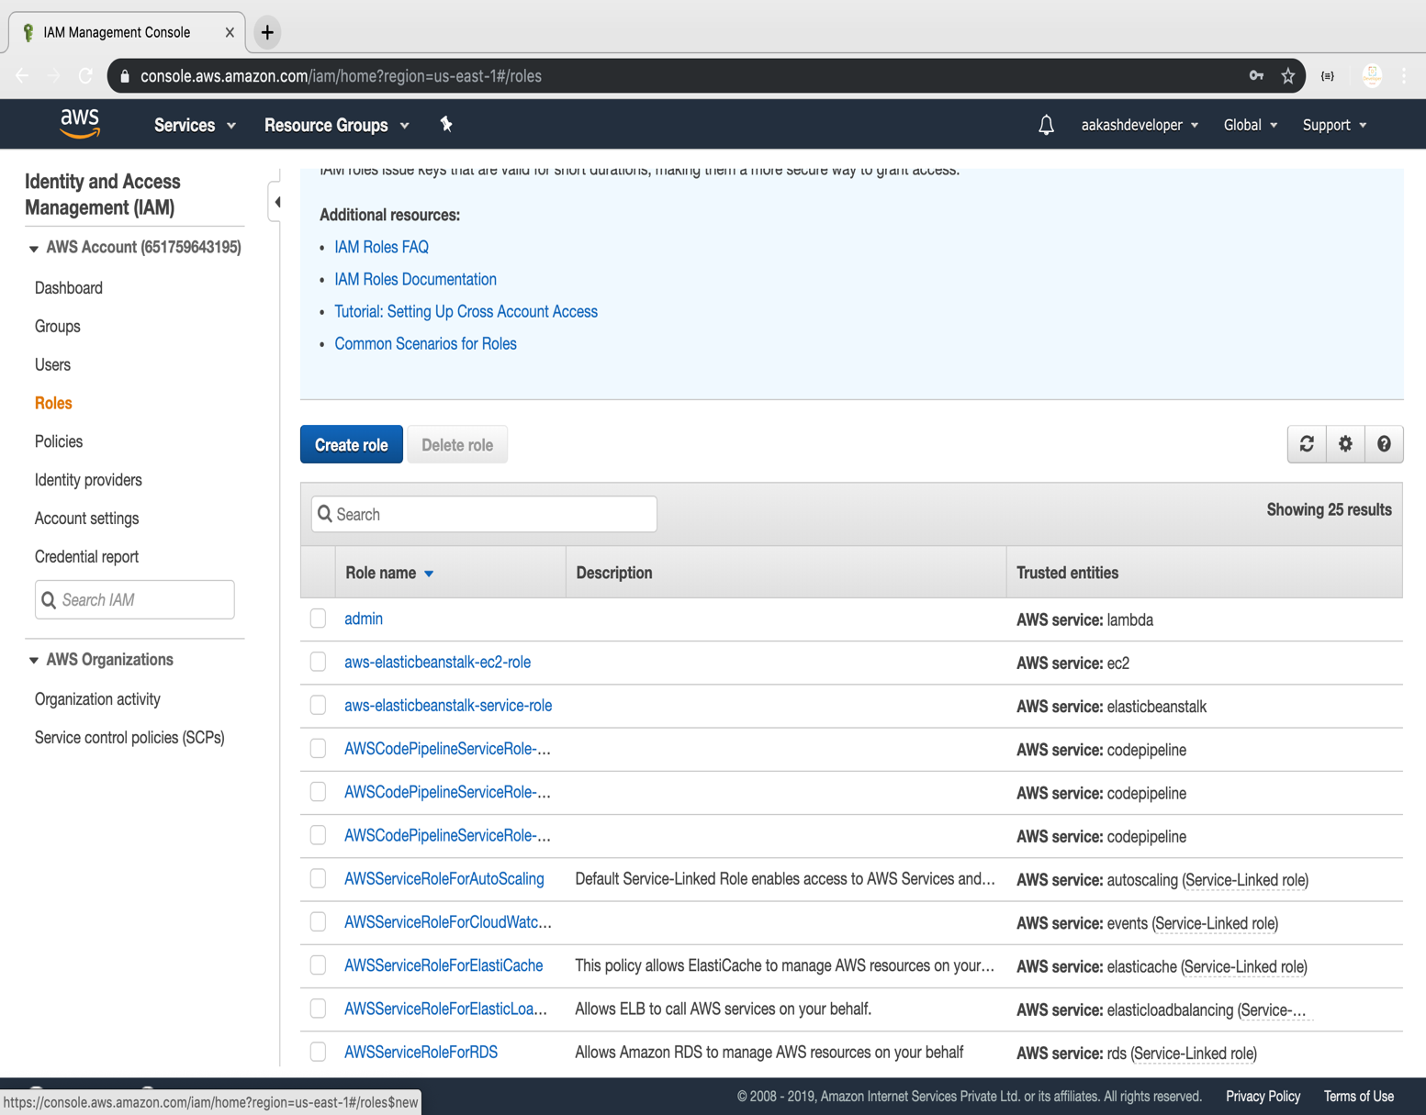

* Select the service

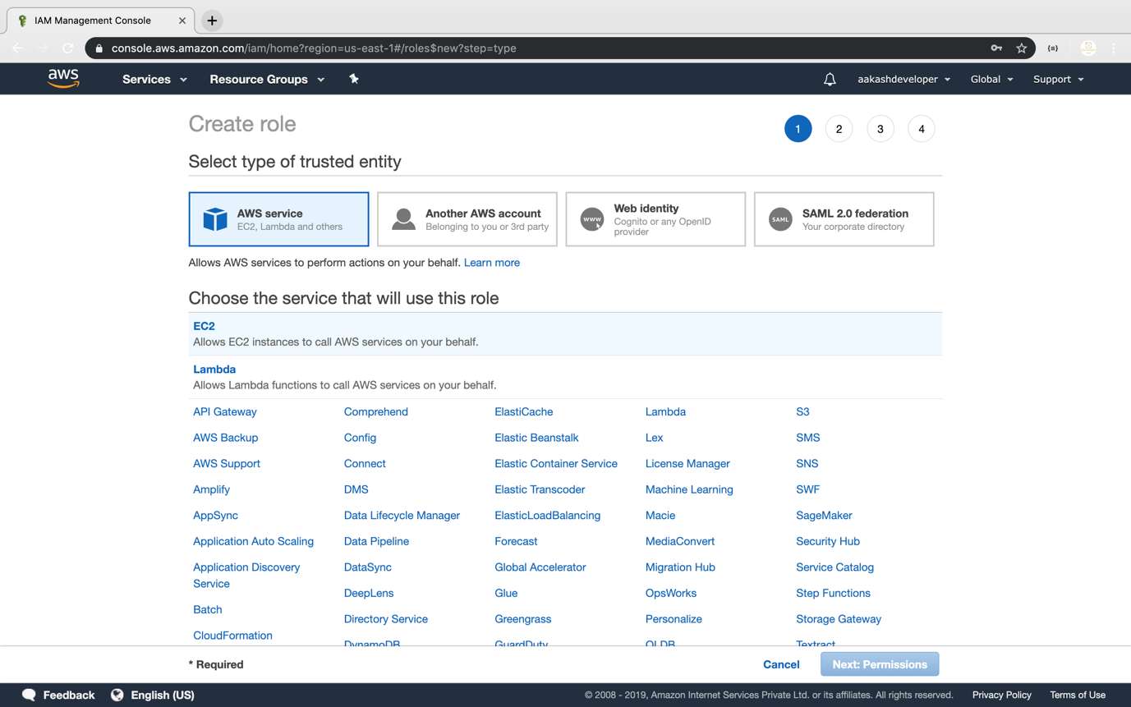

**Step 3.16.2:** Adding AWS policy to the role

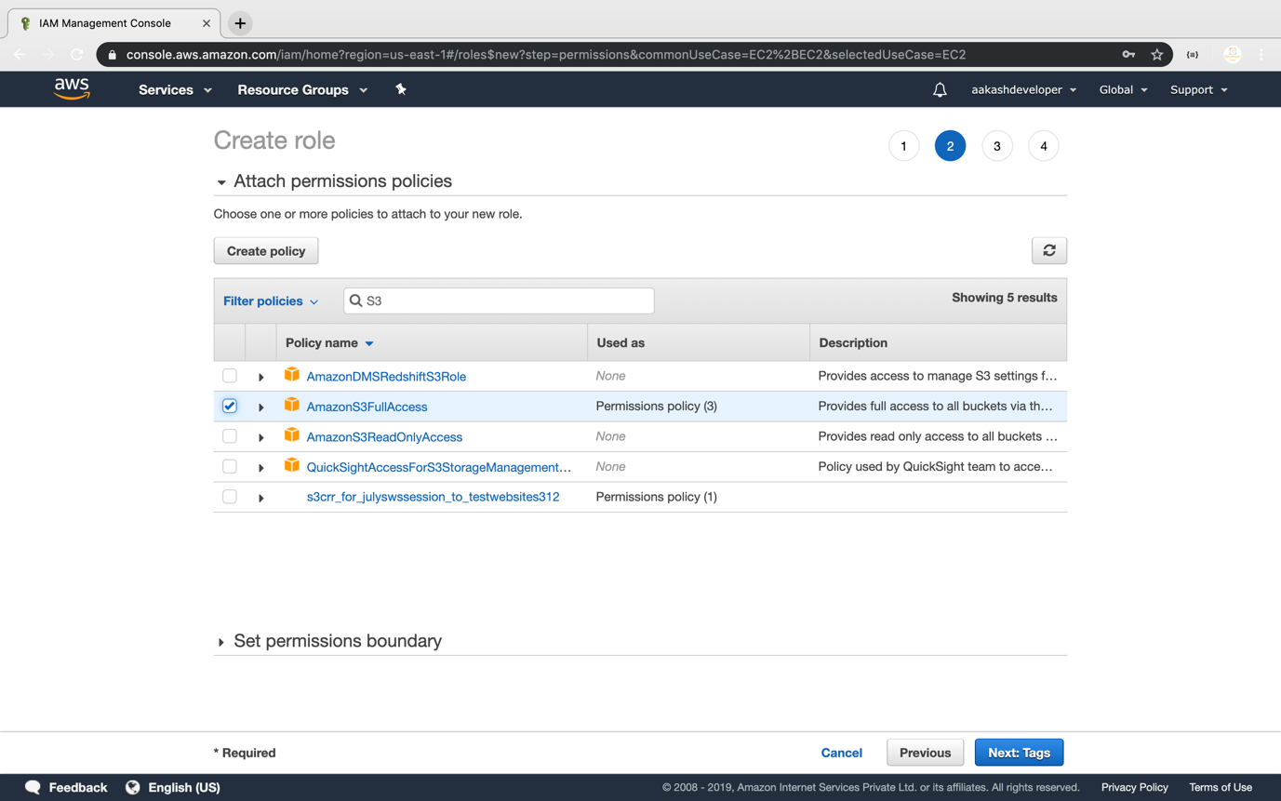

**Step 3.16.3:** Providing a key and a value for the role

* Add a key and a value to the role

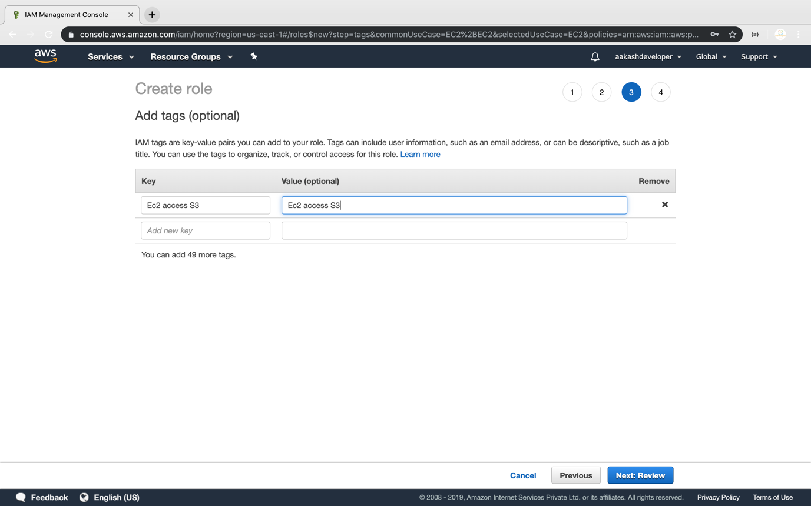

* Add a role:

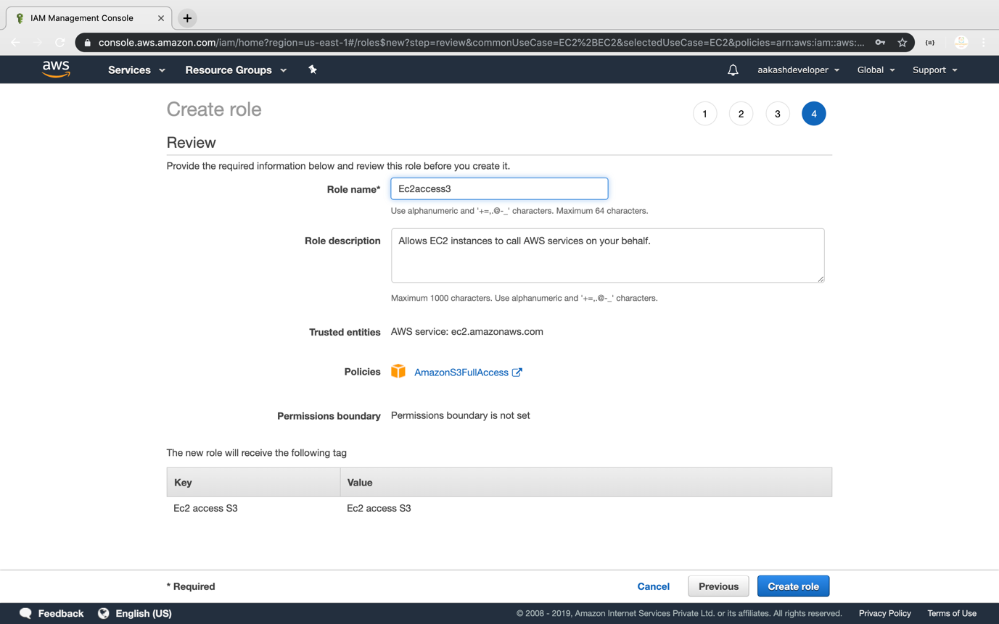

* Once the role is created, you can find it in the IAM panel

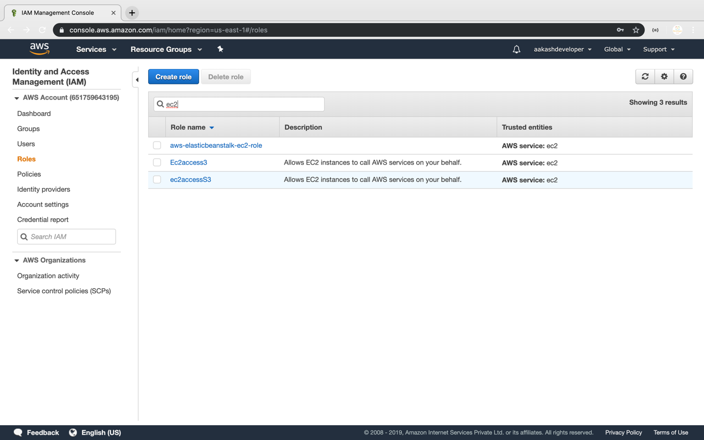

**Step 3.16.4:** Pushing the code to your GitHub repositories

* Open your command prompt and navigate to the folder where you have created your files.

**cd <folder path>**

* Initialize your repository using the following command:

**git init**

* Add all the files to your git repository using the following command:

**git add .**

* Commit the changes using the following command:

**git commit . -m “Changes have been committed.”**

* Push the files to the folder you initially created using the following command:

**git push -u origin master**